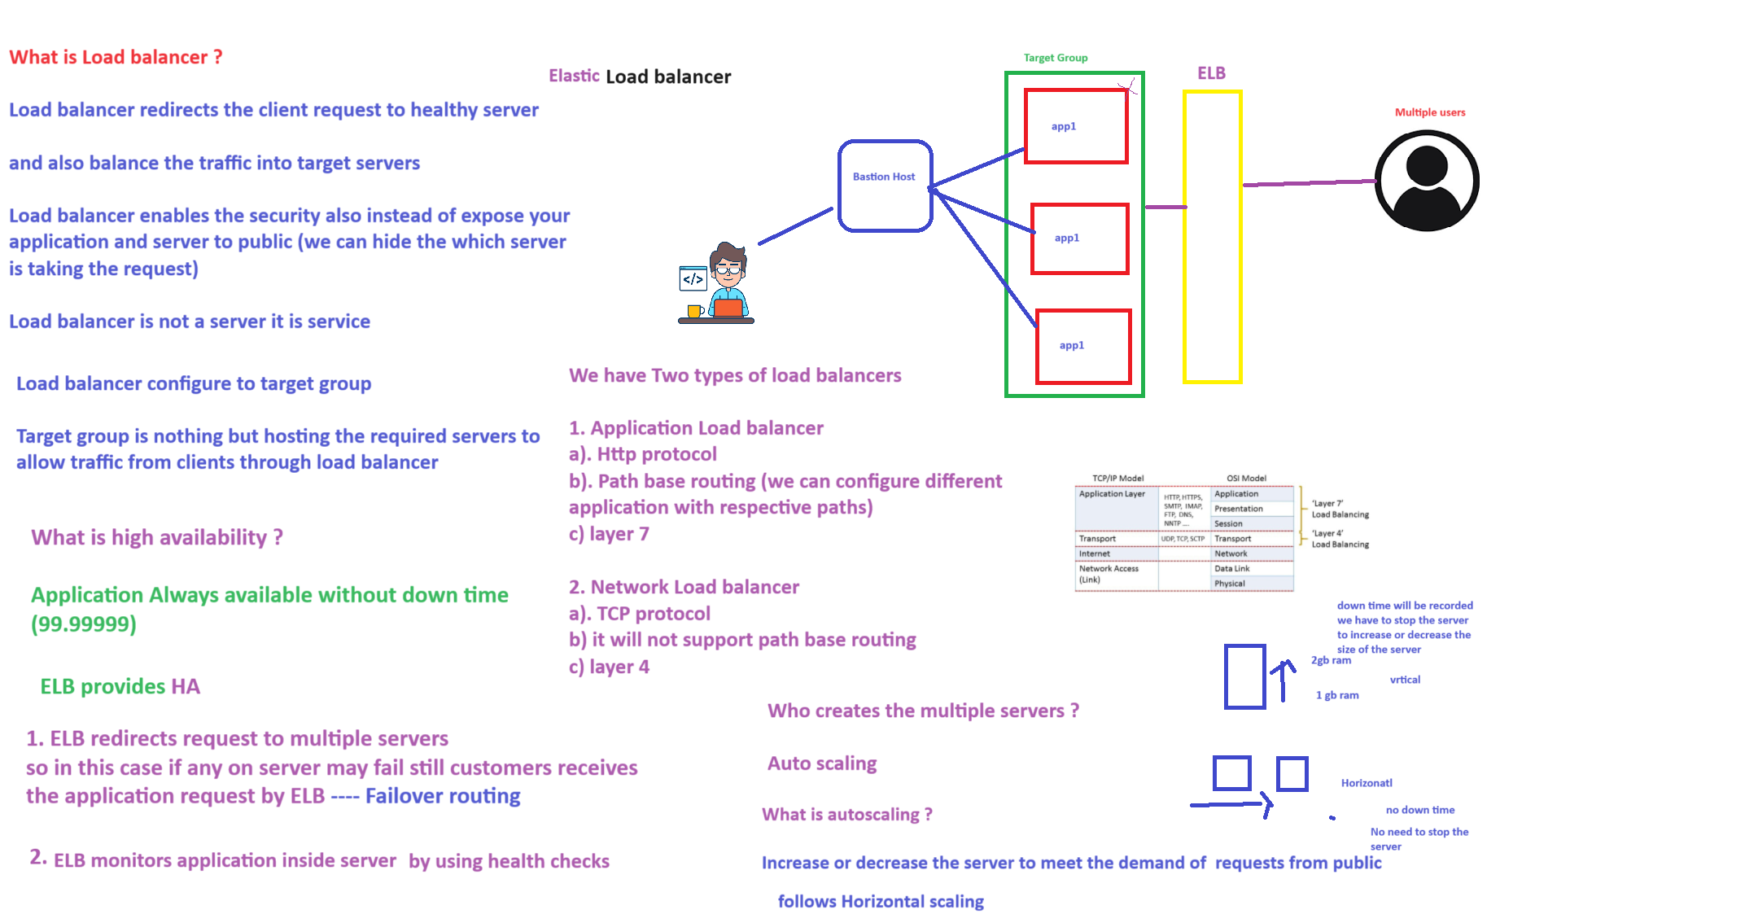

ELB is a service to redirect the server not for write only read.

ELB configure private instance only not for public instance.

Auto scaling

Increase or decrease the server to meet the demand of requests from public, here we are follows horizontal scaling.

Horizontal scaling

No down time will recorded here.

Here duplication of multiple servers take place.

Here no need to stop the server, while increasing or decreasing the server.

Vertical scaling

It means we are increasing or decreasing the server size in one server only.

Here we need to require stopping the server for modifications.

Here down time will recorded.

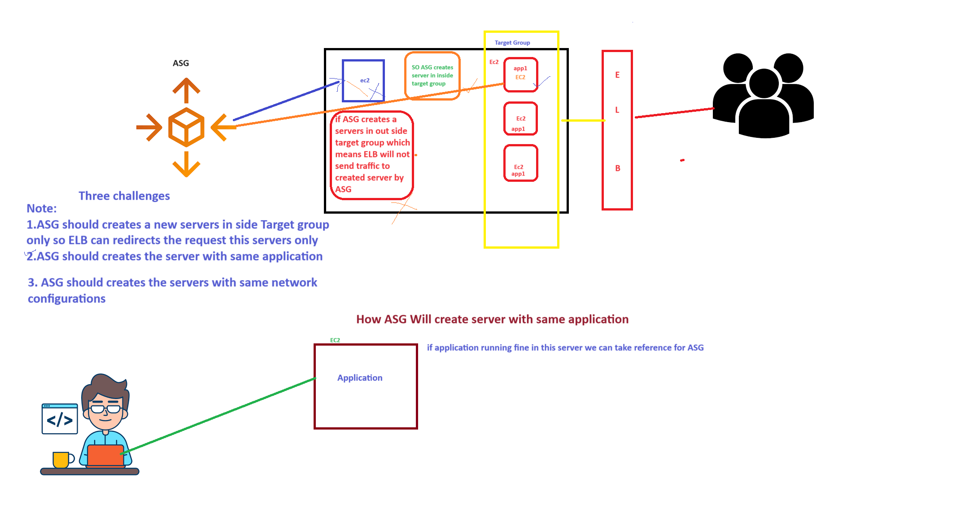

If ASG creates a server outside the target group, which means ELB will not send traffic to created server by ASG.

So ASG have to create Server inside the TG only.